# **How To Clear Cookies and Cache on Google Chrome!**

B

By default, your web browser stores cookies and other information about the sites you visit.  Clearing your browser cache is often the easiest way to fix connection issues with library databases.

To clear your cache in **Google Chrome on Windows and APPLE Computers**

1. Click the **Menu** in the upper right.
2. Choose **History or Setting  
   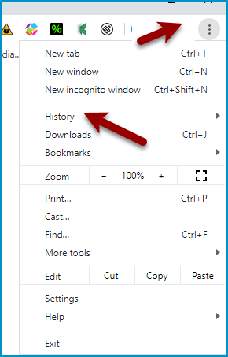**
3. OR   
   A screenshot of a computer

   Description automatically generated
4. Choose "**Delete browsing Data**."  
   A screenshot of a computer

   Description automatically generated
5. The most effective setting is to clear all browsing history **for All time** and to clear **browsing history, download history, cached images**and files, and **cookies**.   
   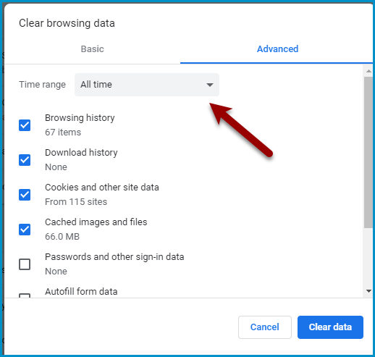
6. Choose Clear data! (**Once data is cleaned the box should disappear**)

**How to Clear your Cache and Cookies in Safari!**

1. **Click on Safari on the top menu bar.**

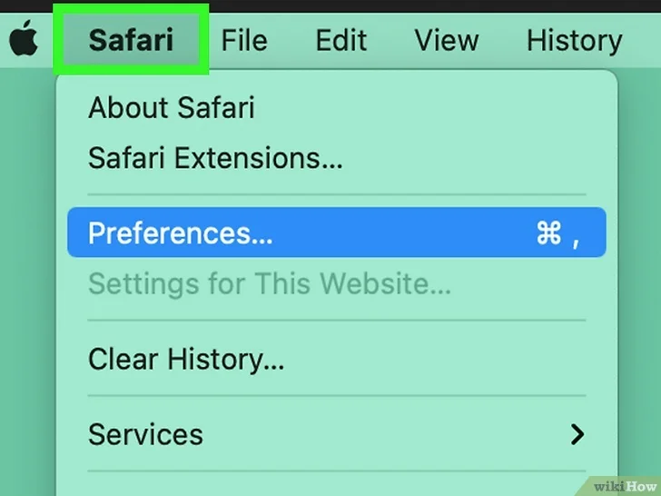

1. **Click Settings…. You can find this in the drop-down menu.**
   1. 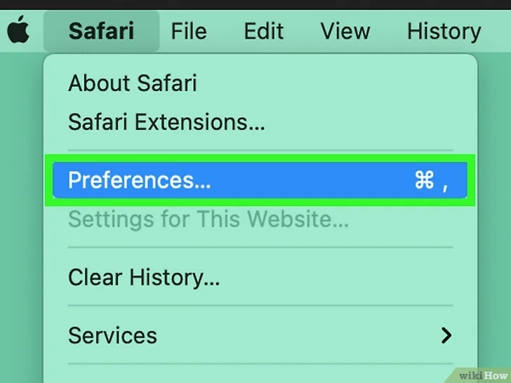
2. **Click Privacy. This is the tab at the top.**
   1. 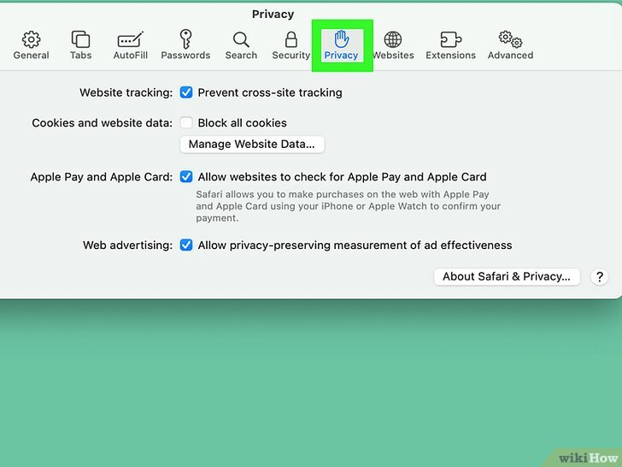
3. **Click Manage Website Data. A new page will open.**
   1. 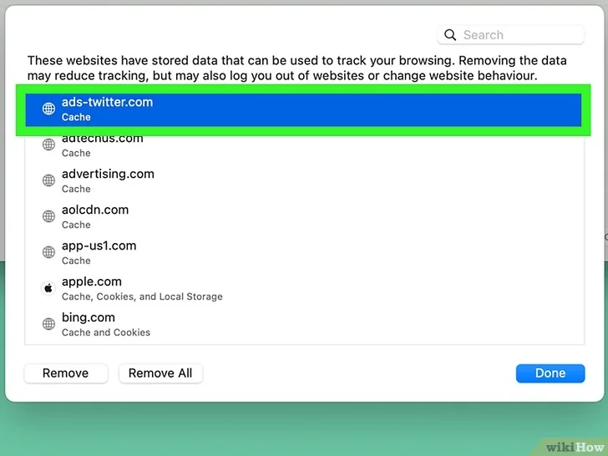
4. **If you select more than one website, you'll need to click Remove All. CHOOSE REMOVE ALL!A screenshot of a computer

   Description automatically generated**